**JENKINS AND NGNIX**

**STEP 1:** Install Ubuntu and use the Ubuntu OS

**STEP2 :** Open the terminal in the Ubuntu

**STEP 3:** Make sure your Ubuntu has java . If not install java using

**sudo apt install openjdk-17-jdk -y**

**Once you install java , check the version like this below image**

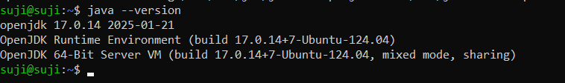

**STEP 4:** Now install jenkins , create a **nano filename.sh** file and add the following commands

**sudo wget -O /usr/share/keyrings/jenkins-keyring.asc \**

[**https://pkg.jenkins.io/debian-stable/jenkins.io-2023.key**](https://pkg.jenkins.io/debian-stable/jenkins.io-2023.key#inbox/_blank)

**echo "deb [signed-by=/usr/share/keyrings/jenkins-keyring.asc]" \**

[**https://pkg.jenkins.io/debian-stable**](https://pkg.jenkins.io/debian-stable#inbox/_blank)**binary/ | sudo tee \**

**/etc/apt/sources.list.d/jenkins.list > /dev/null**

**sudo apt-get update**

**sudo apt-get install jenkins**

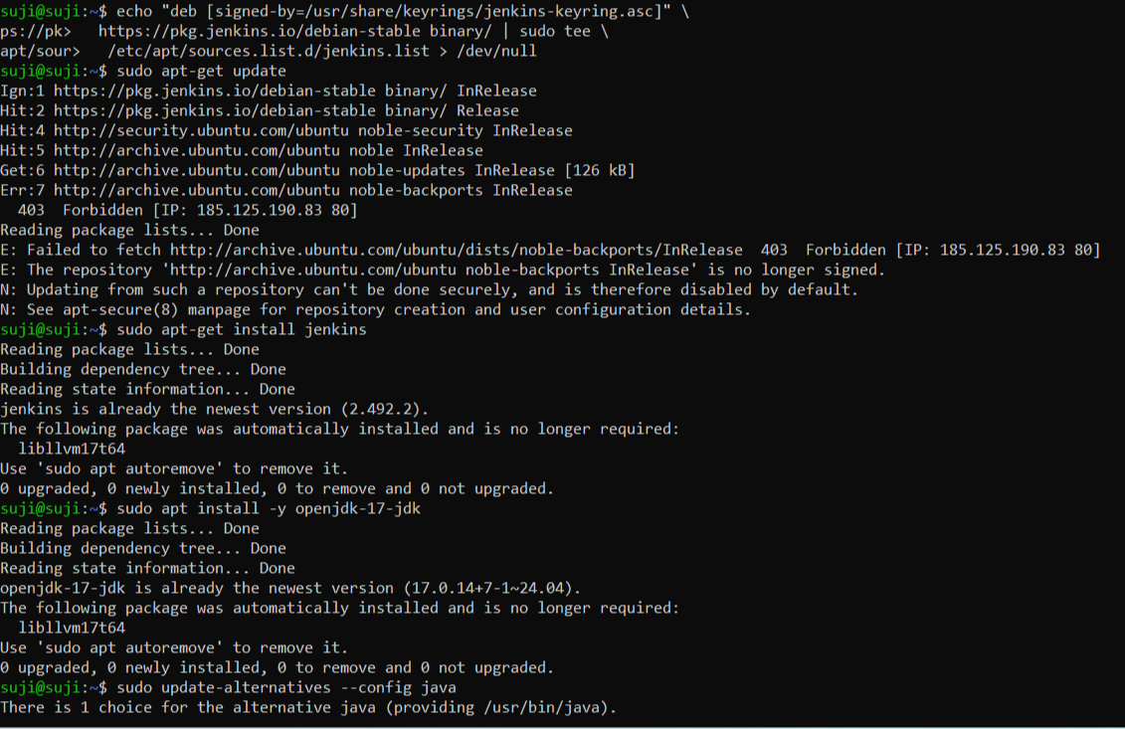

**STEP 5 :** Run the file using bash filename.sh

You will get the following terminal window like below

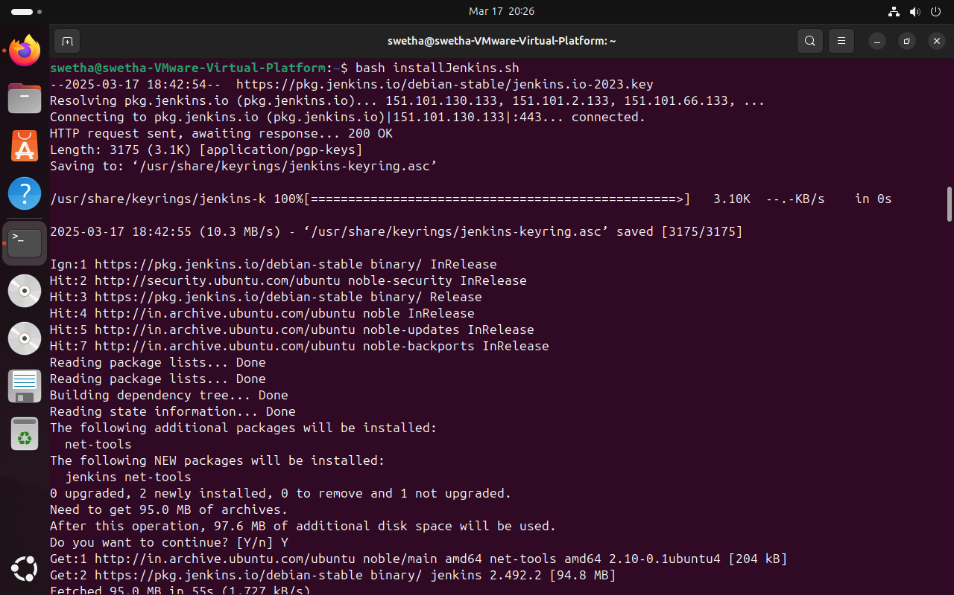

**STEP 6:** After step 5 , run the follwing commands to run the jenkins

**sudo systemctl enable jenkins**

**sudo systemctl start jenkins**

**sudo systemctl status jenkins**

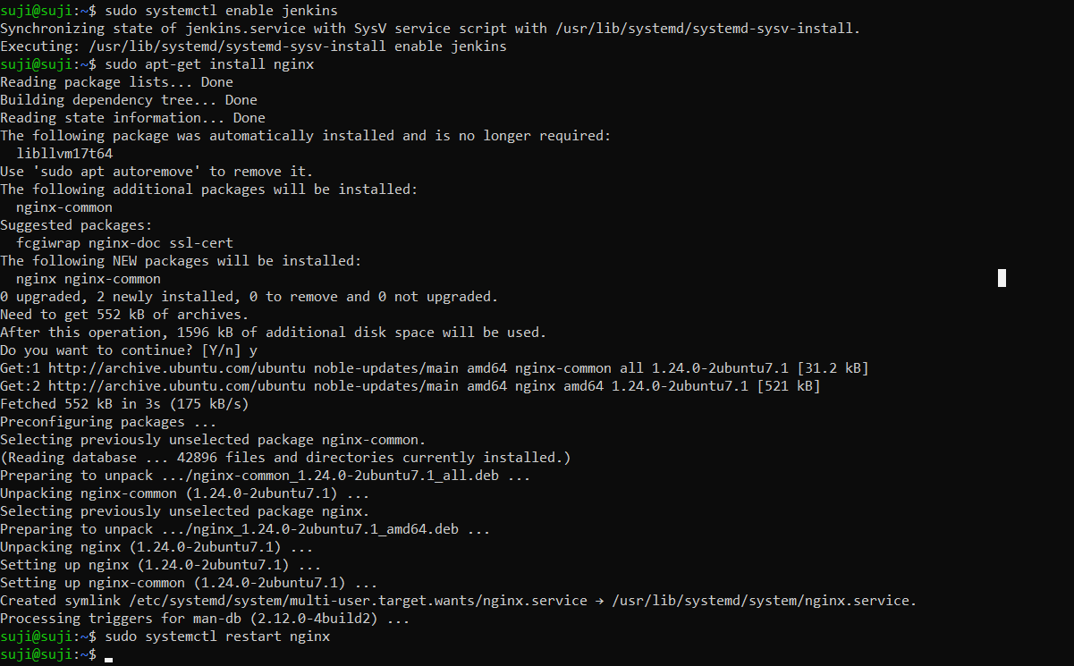

**STEP 7:** Now your jenkins in run , go to localhost:8080 , you should see the administration page .

**STEP 8** :In the terminal again type the following command ,

**sudo cat /var/lib/jenkins/secrets/initialAdminPassword**

**STEP 9:** Now you have your password generated , enter this password in the admin page and enter basic details and finish necessary resources installation and you,ll be taken into the jenkins interface .

**STEP 10**: Give your project a name , and in configure in the shell , type in the following commands and save it .

**#!/bin/bash**

**# Update package lists**

**sudo apt update -y**

**# Install Nginx**

**sudo apt install -y nginx**

**# Start and enable Nginx**

**sudo systemctl start nginx**

**sudo systemctl enable nginx**

**# Verify Nginx is running**

**systemctl status nginx**

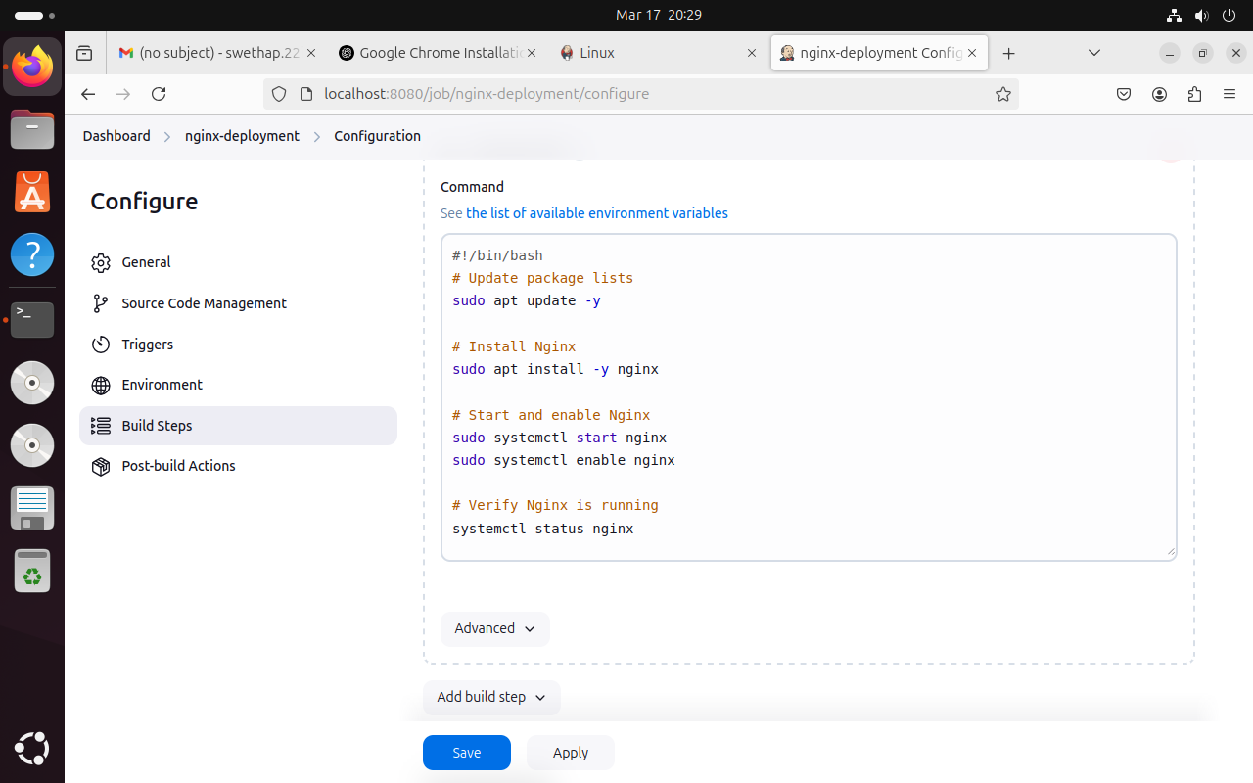

**STEP 11:** Go to your terminal and run the following command ,

**sudo apt-get install nginx**

**sudo systemctl restart nginx**

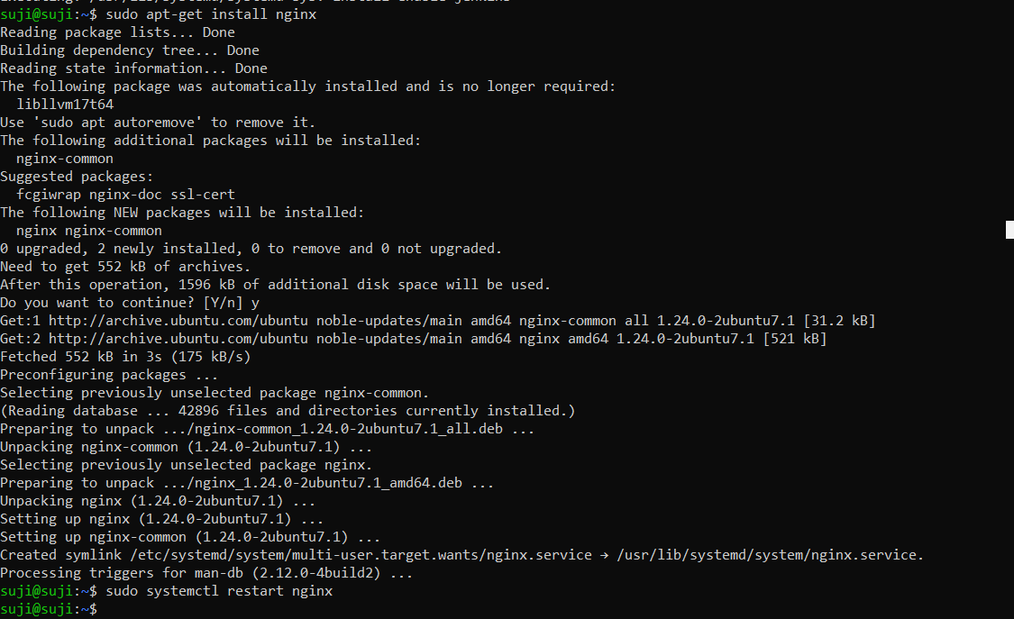

**STEP 12:** If you have a successful build , your console output looks like this !

